Marmara Üniversitesi Mühendislik Fakültesi
Elektrik-Elektronik Mühendisliği

Laboratory Manual

EE 3011
Electronics I

Experiment (1)
Diode Rectifier with Peak Detector

Name | ID | Section
Yunus Emre Turunç | 150721854 | Face to Face
Bahadır Çalık | 150720021 | Face to Face

Spring 2023

Objectives
Experiment (1)
Diode Rectifier with Peak Detector

- To study the half-wave rectifier function.
- To analyze the output of a peak detector with regulator.

Pre-lab Work
Analyze the circuit below using the constant voltage diode model. The input is a sinusoidal wave with amplitude 𝑉! and frequency 𝑓. Find 𝑉" with and without the capacitor 𝐶. In each case, draw the waveform of the output and find the average output voltage and average load current.
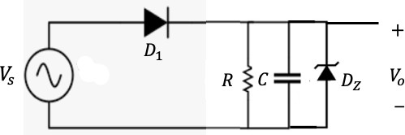
Solution

Figure 1: Half-wave rectifier with peak detector and regulator.

Equipment

Table 1. Equipment for experiment 5.

Page2
 | Equipment | Model | Serial No. | Stock No.
1 | BreadBoard Station
2 | 1 kΩ Resistor (2W, 5%)
3 | Capacitors (2)
4 | Diodes (2) | 1N4001 (1) 1N4732 (1)
5 | Multi-meter (1)
6 | Dual-trace Oscilloscope
7 | Probes and Cables

Experimental Procedure
Part (1): Half-wave Rectifier Output Analysis.
- Connect the circuit in figure 1 without the capacitor and the Zener diode and with 𝑅=1 kΩ. Pay a special attention to how you connect the terminals of the diode. The input voltage source
𝑉# is sinusoidal.
- Connect channel 1 of the oscilloscope to 𝑉# and adjust it to 10 V amplitude at 60 Hz. Pay attention to the polarity of the oscilloscope connection. Sketch the input waveform in graph 1 labeling all important points in both voltage and time axes. Make your sketch as accurate as possible.




- Now connect channel 2 of the oscilloscope to 𝑉$. Sketch the output waveform on the same graph 1 labeling all important points in both voltage and time axes. Make your sketch as accurate as possible. Use different colors for the waveforms.
- Using the multi-meter, measure the output voltage and record it in table 2.
- Repeat steps 1-4 for a triangular 𝑉# waveform. Use graph 2 for the sketches. Part (2): Half-wave Rectifier with Peak Detector and Regulator.
- Consider again the circuit in figure 1 with the capacitor connected only.
- Repeat the whole procedure in part 1 for both capacitors provided. Record results in graphs 1 and 2 and table 3. Use different colors for the waveforms.
- Finally, connect the Zener diode across the capacitor and observe the output. Record results in graphs 1 and 2. Use different colors for the waveforms.

Results and Analysis

Part (1): Half-wave Rectifier Output Analysis.
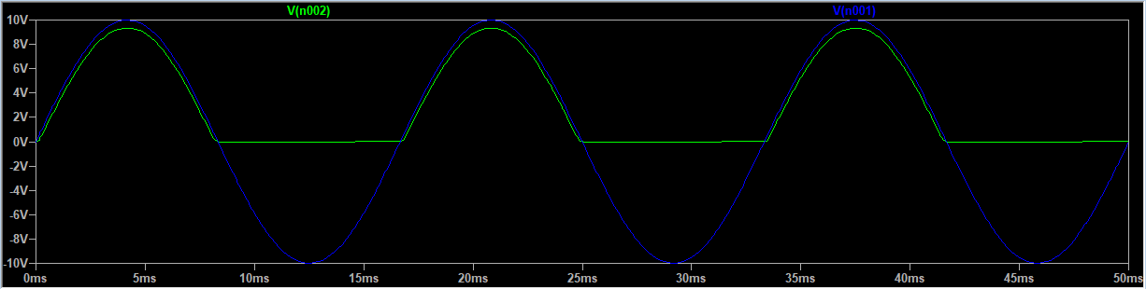

Graph 1: Sinusoidal input case.

Table 2. Average output voltage of the half-wave rectifier without peak detector.
Sinusoidal input Triangular input

Page3
𝑉0 (ave) Experimental value
$$3.08$$
2.89 V
𝑉0 (ave) Theoretical value

%
Difference
$$6,57$$
𝑉0 (ave) Experimental value
$$4.65 V$$
4.83 V
𝑉0 (ave) Theoretical value

%
Difference

$$0,22$$
Laboratory Pictures
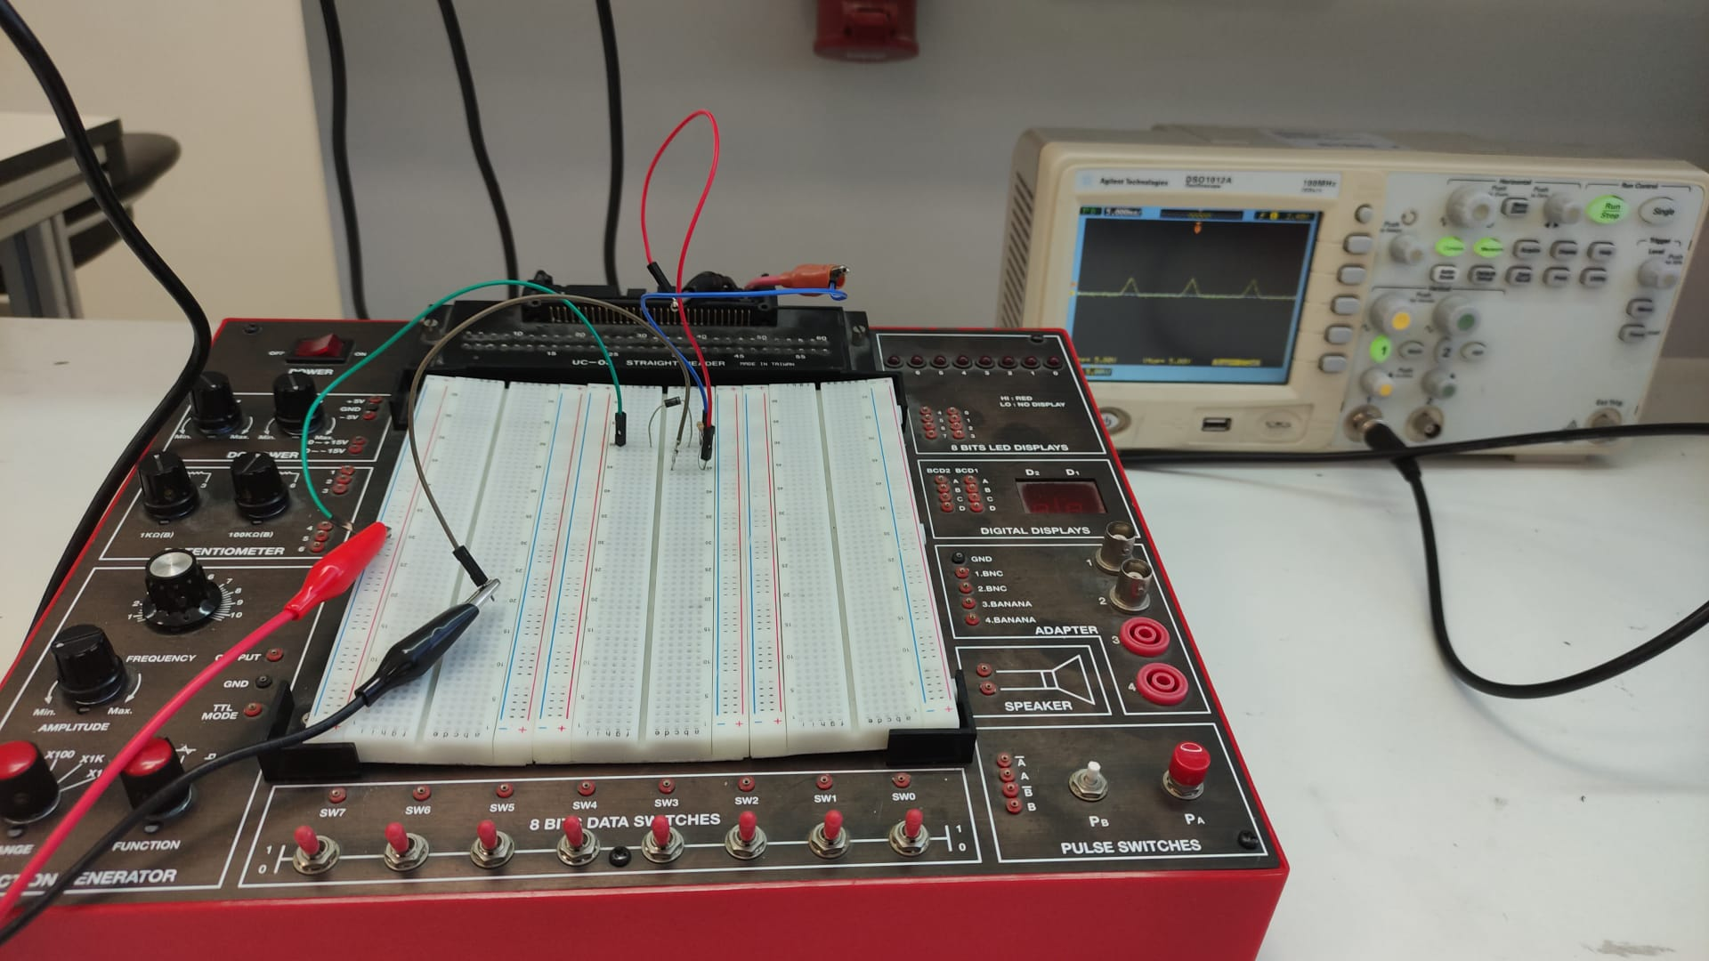
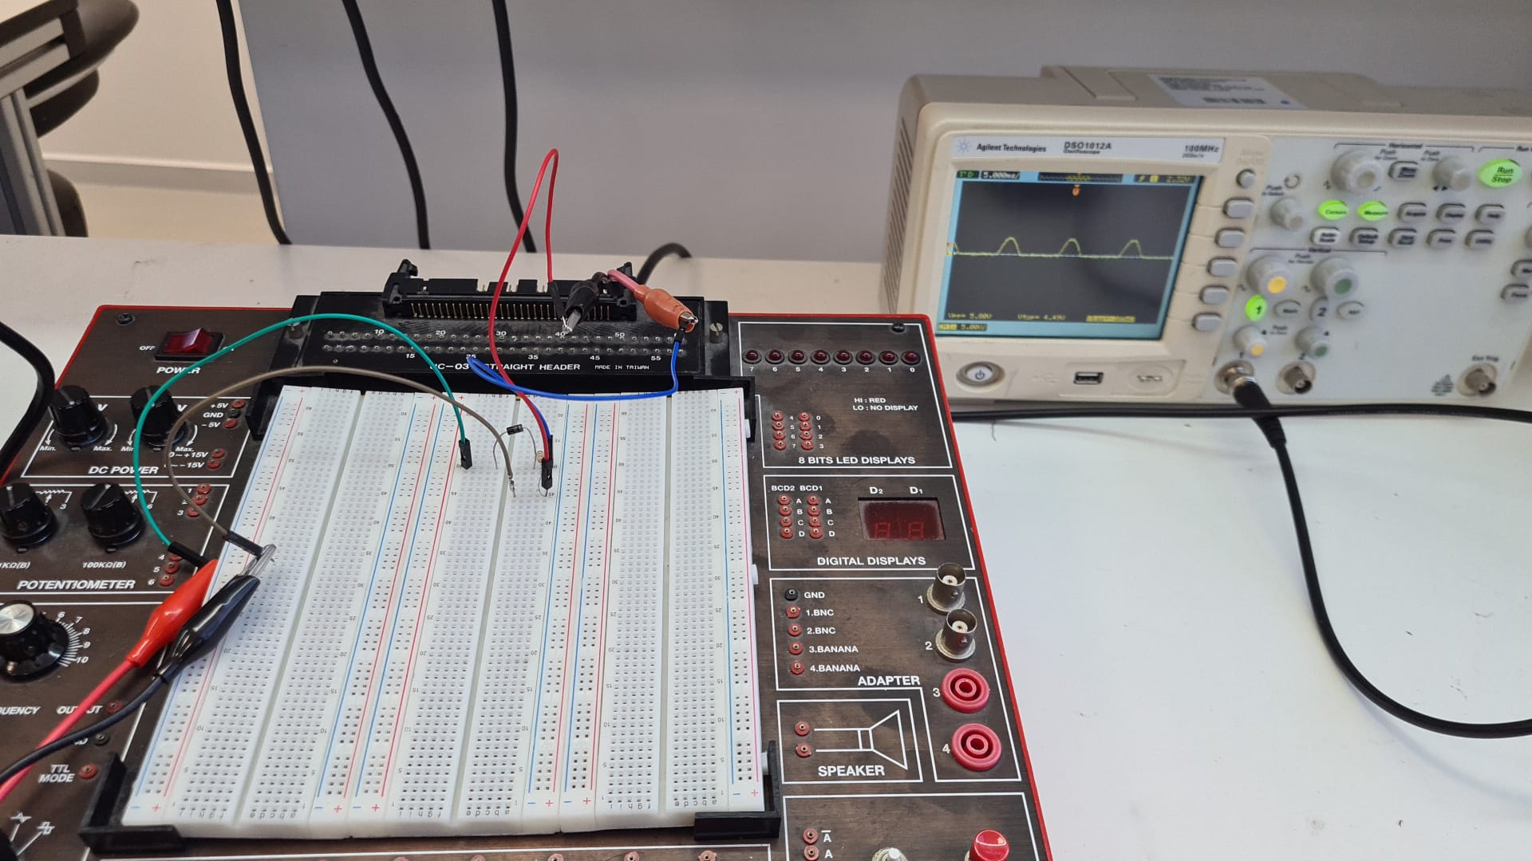
Sinusoidal Waveform Input

Triangular input Calculations

$$V_{0(aveTheoretical)}=\frac{V_{0}}{2}=4.65 V$$

$$\%_{(Difference)}=\%0,22$$

Sinusoidal input Calculations

$$V_{0\left(aveTheoretical\right)}=\frac{V_{0}}{π}=3.08$$

$$\%_{(Difference)}=\%6,57$$

Triangular Waveform Input
Page4

Page5

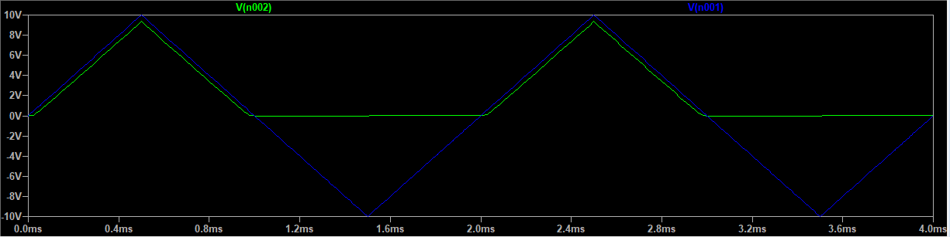

Graph 2: Triangular input case.

- Comment on your results regarding the waveforms in graphs 1 and 2.

The main difference between these two waveforms is their shape and the way they vary over time. Sinusoidal waveforms are smooth and continuous, while triangular waveforms are jagged and discontinuous. Additionally, sinusoidal waveforms have a continuously varying voltage amplitude, while triangular waveforms have a constant voltage rise and fall rate.

- Comment on your results regarding the average output voltage.
The difference between the average output voltage of a sinusoidal waveform and a triangular waveform in the same circuit is due to the different mathematical properties of the two waveforms. The average output voltage of a sinusoidal waveform depends on its RMS voltage, while the average output voltage of a triangular waveform depends on its maximum voltage.

Part (2): Half-wave Rectifier with Peak Detector and Regulator.

Table 3. Average output voltage of the half-wave rectifier with peak detector.

 |  | Sinusoidal input |  |  | Triangular input
 | Capacitor value (µF) | 𝑉0(ave) Experimental value | 𝑉0(ave) Theoretical value | %  Difference | 𝑉0(ave) Experimental value | 𝑉0(ave) Theoretical value | %  Difference
Without Zener Diode | 30 | 7.6 V | 6.717 V | 11.62 | 6.96 V | 7.3 V | 0.5
With Zener Diode | 30 | 7.3 V | 7.63 V | 0.5 | 7.76 V | 7.91 V | 0.61

- Comment on your results regarding the waveforms in graphs 1 and 2.

In a half-wave rectifier circuit with a sinusoidal input waveform, the output voltage waveform would be a smooth, continuous waveform with a small voltage ripple caused by the filtering action of the capacitor. However, when a triangular waveform is used as the input, the output voltage waveform would have a sawtooth-like shape with a larger voltage ripple due to the sharp edges of the waveform.

The voltage ripple in the output waveform is caused by the fact that the capacitor is charged only during the positive half-cycles of the input waveform and discharged during the negative half-cycles. In the case of a triangular waveform, the rate of change of the waveform is faster than that of a sinusoidal waveform, causing the capacitor to charge and discharge more rapidly, resulting in a larger voltage ripple.

- Comment on your results regarding the average output voltage

The output voltage would still be regulated by the capacitor and zener diode combination, but the voltage ripple would be larger due to the sharper edges of the sawtooth waveform. This would require a larger capacitor value to smooth out the waveform and reduce the voltage ripple.
In our case we used a 30uF capacitor and we can see the voltage ripple on the capacitor looking at the graph and calculations.
The effect on the output voltage can be minimized by increasing the capacitance value of the capacitor, which would result in a smoother output voltage waveform with a smaller voltage ripple.

Page6

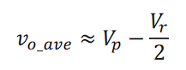
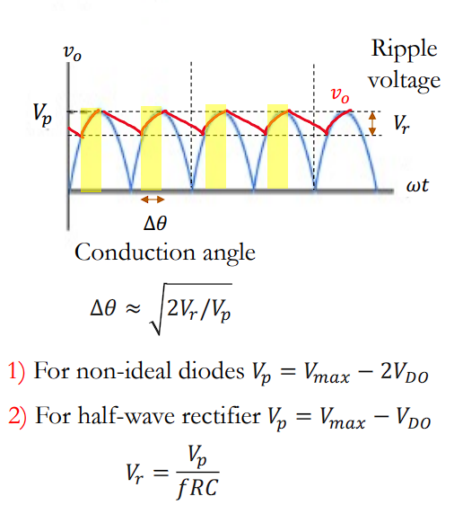
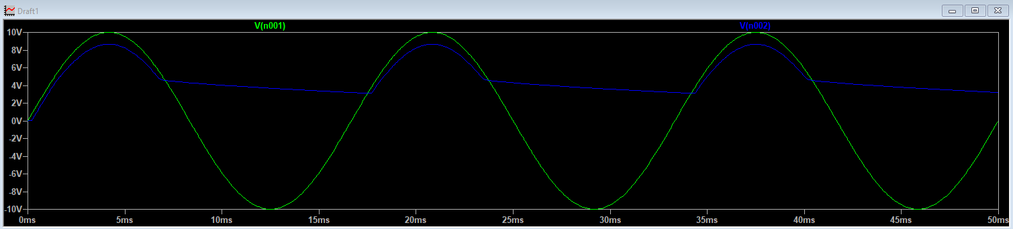
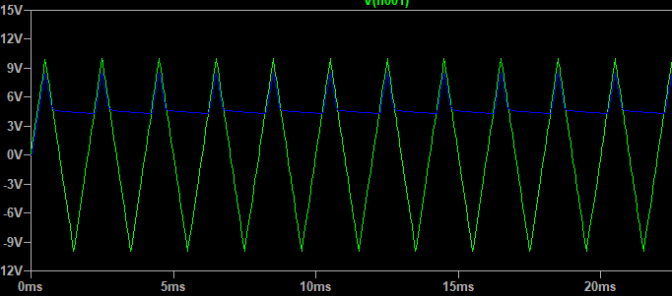
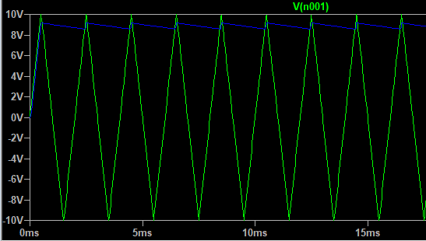
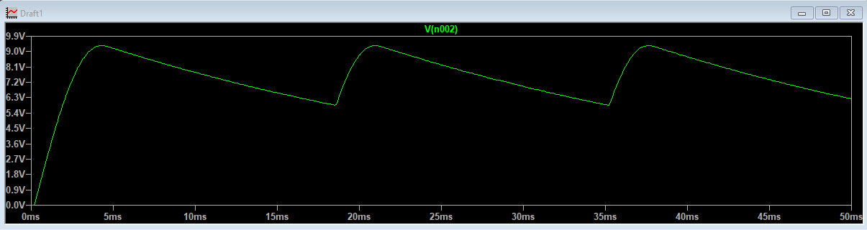
CALCULATIONS

$$V_{r}=\frac{9,3}{60*1000*30*{10}^{-6}}=5.166V$$

$$V_{0(aveTheoretical)}=V_{p}-\frac{V_{r}}{2}=6.717$$

$$V_{0(aveExperimental)}=V_{p}-\frac{V_{r}}{2}=7.6$$

$$\%_{(difference)}=11.62$$

Without Zener Diode With Zener Diode (Sinusoidal Wave)
With Zener Diode (Sinusoidal Wave)
Without Zener Diode (Sinusoidal Wave)
Page7

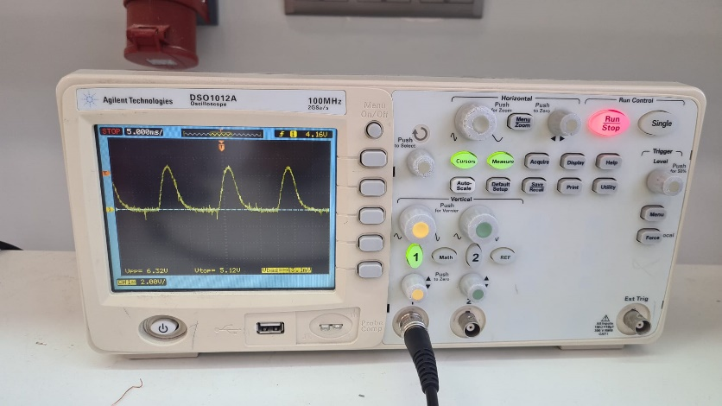
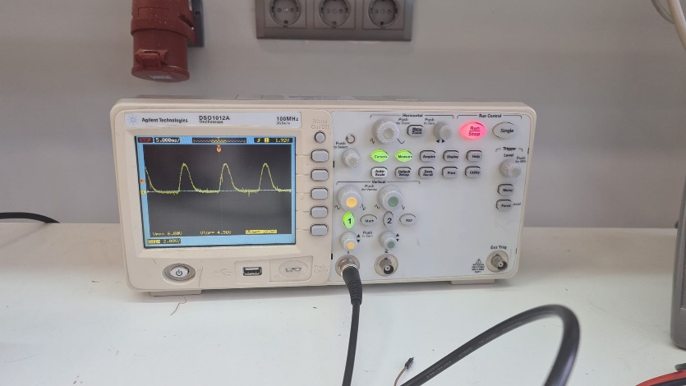

With Zener Diode (Sinusoidal Waveform)
Without Zener Diode (Sinusoidal Waveform)

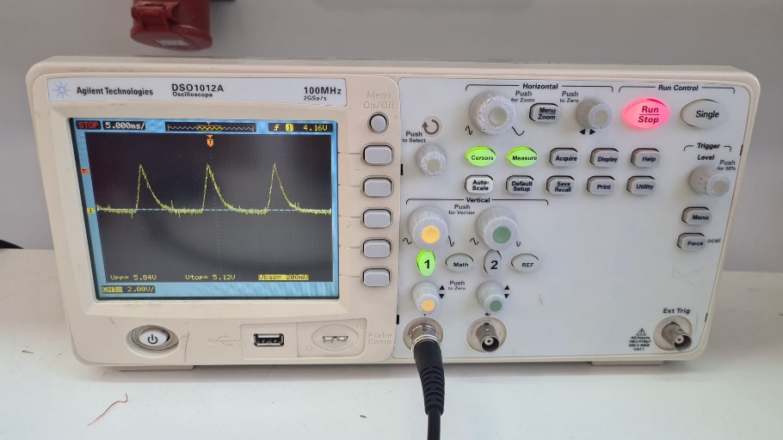
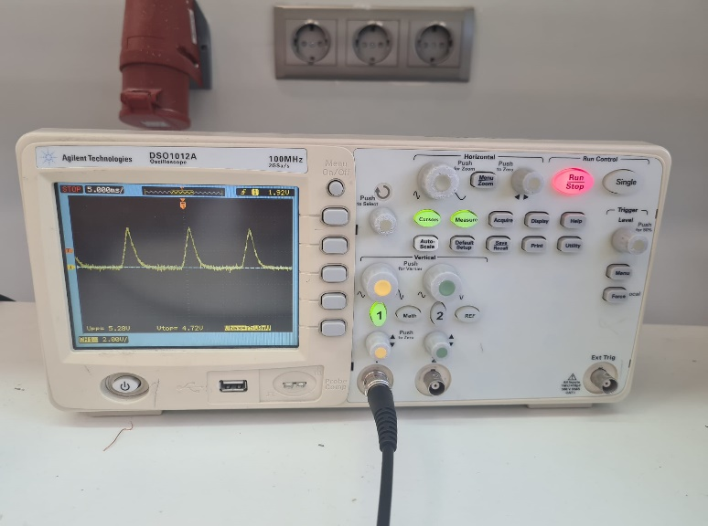

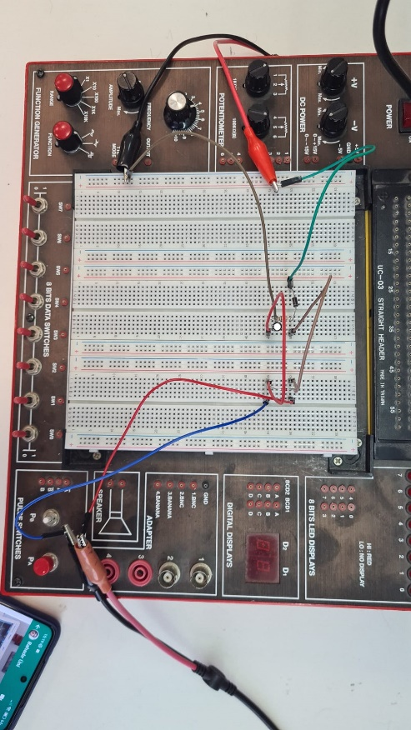

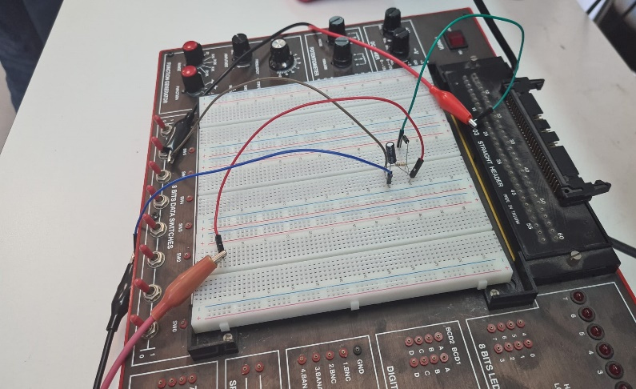

With Zener Diode (Triangular Waveform)
Without Zener Diode (Triangular Waveform)

Conclusions

In this experiment, we have handled three different situations and observed what are the results.

In the first situation, an ideal diode(1N4001) is series connected with a 1kΩ resistor. The circuit reduces the input voltage using the diode and the resistor in series. However, the output voltage value only includes the positive half of the sinusoidal wave and be lower the input voltage.

In the second situation, an ideal diode(1N4001) is serially connected with a parallel connected 1kΩ resistor and 30µF capacitor. It is created a low-pass filter circuit that attenuates high-frequency signals while allowing low-frequency signal to pass through the circuit.

In the third situation, an ideal diode(1N4001) is serially connected with a parallel connected 1kΩ resistor,30µF capacitor and a Zener diode(1N4732). The Zener diode functions as a voltage regulator to maintain a constant output voltage. The appropriate Zener diode voltage rating and resistor value must be selected based on the desired output voltage and Zener current requirements.

In the case which we have triangular waveform signal at first, we observe that the output waveform is affected by the non-linear characteristics of the diodes in the circuit. We also learned that the diodes only conduct when the input signal is greater than their forward voltage drop, and the output waveform has a distorted shape due to the non-linear voltage-current relationship of the diodes.

In conclusion, as we add a new element to the circuit, we obtain different functions such as rectification and regulation and our circuit is transformed from AC to DC in every step. In addition, as we change the input signal, the output may change proportionally in some cases.

Page8

